**iLearn :** **Data Mining and visualization ABC**

This is brought by iLearn sessions from SUNY Albany, 2020 Feb.

contact: Susan Qian Liu qliu20@albany.edu

Interested in scraping data from the internet? Try to visualize them while analyzing? Come and explore with different tools from easy-to-use text scraping plug-in to python. Walk-ins are welcome.

Tools to prepare:

1. Plug-in tool data miner
2. Python installation

# Plug-in tool data miner

1. Install chrome browser
2. Prepare a google account
3. Find data miner plug-in and install it



1. Start a new recipe

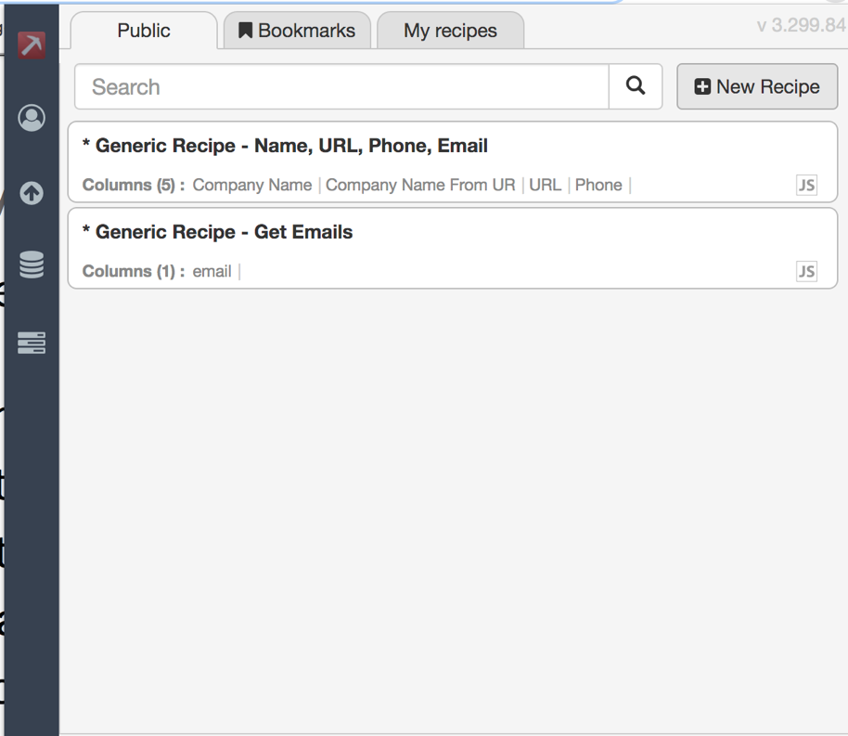

1. Tutorials available

<https://www.youtube.com/watch?v=bpyX8G7wopQ>

# Python installation

1. Download and install anaconda

<https://docs.anaconda.com/anaconda/install/>

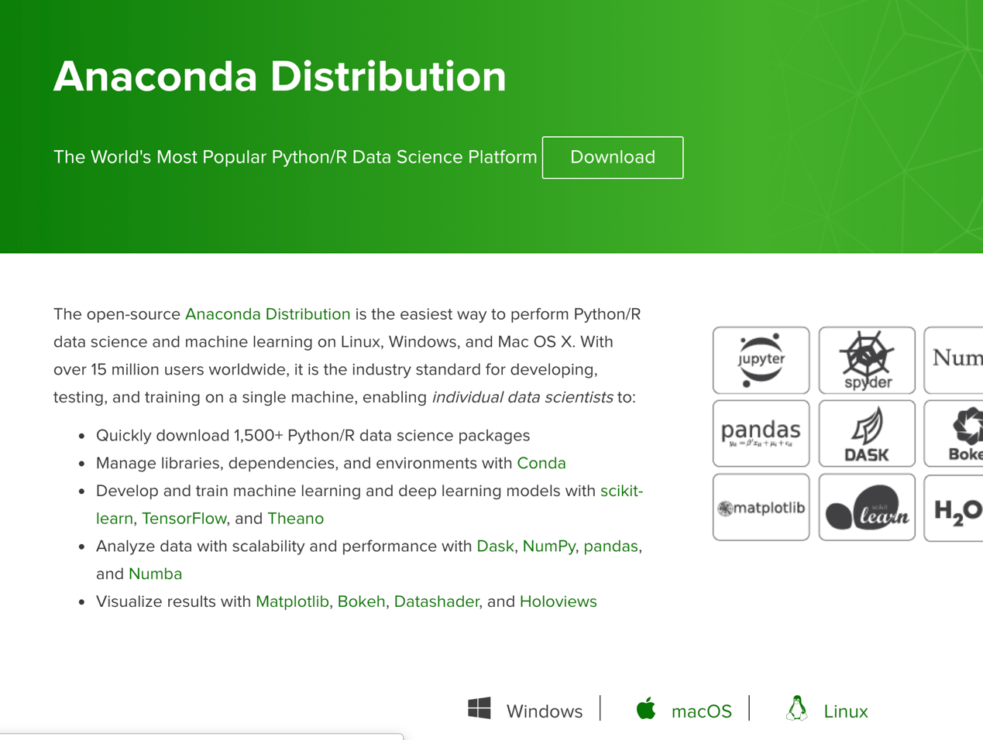

1. Open jupyter notebook

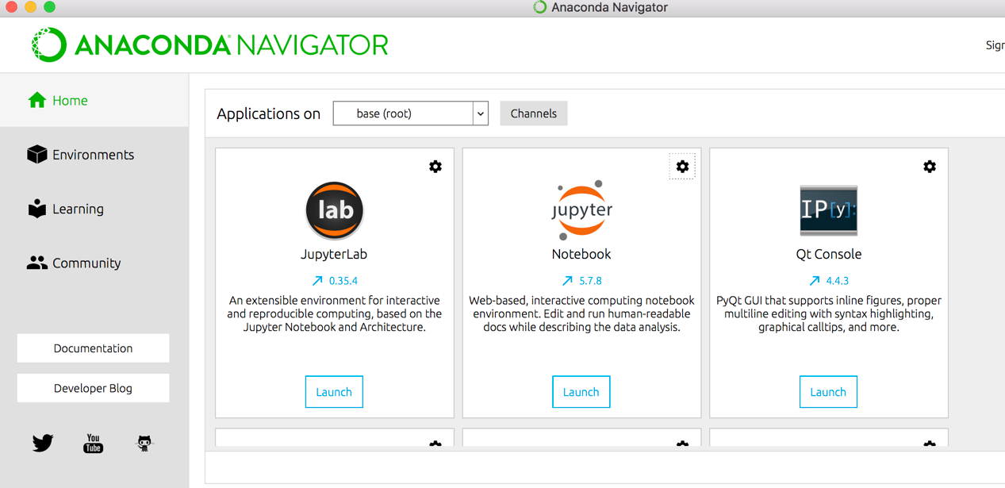

1. Start first coding experience with python
2. Create a new folder

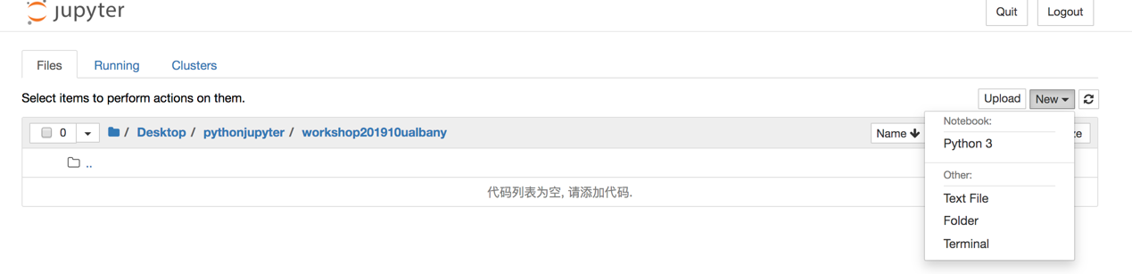

1. Start a new python3 file

